1. INTRODUCTION
1.1. Project Overview
AutoSage is an AI-powered application that provides detailed information about two-wheeler and four-wheeler vehicles using image-based analysis. The system uses Google’s Gemini Flash model to analyze vehicle images and generate structured details such as brand, model, mileage, price range, and resale value. AutoSage simplifies the vehicle selection process by delivering real-time insights through an easy-to-use Streamlit interface.
- Scenario 1: Buying a New Motorcycle
Sarah uses AutoSage to compare motorcycle specifications, features, and prices within her budget, helping her make an informed purchase decision.
- Scenario 2: Vehicle Maintenance Tips
AutoSage provides seasonal maintenance suggestions, such as checking tire pressure and battery health, to help users maintain vehicle safety and performance.
- Scenario 3: Finding Eco-Friendly Vehicles
Emma uses AutoSage to explore electric and hybrid vehicles by understanding efficiency, environmental impact, and available incentives.
1.2. Objectives
The primary purpose of the AutoSage project is to develop an intelligent Generative AI–based system that can automatically analyse vehicle images and provide detailed vehicle information. It aims to assist users such as vehicle buyers, owners, and eco-conscious consumers by enabling quick and accurate understanding of two-wheeler and four-wheeler details reducing manual research and improving decision-making efficiency.
Key Objectives:
- To analyse vehicle images using a multimodal Generative AI model.
- To generate structured vehicle details such as brand, model, mileage, price and resale value.
- To build a simple user-friendly web application using Streamlit.
- To enable real-time vehicle comparison and information retrieval for practical use cases.

2. IDEATION PHASE
2.1. Problem Statement
Customers who want to buy or compare two-wheelers and four-wheelers often find it difficult to get clear and complete vehicle information in one place. They try to understand details such as brand, model, mileage, features, price, and resale value, but the information is scattered across multiple websites. Most platforms require manual searching and reading long, complex specifications, which is time-consuming and confusing. Existing systems do not use image-based AI to provide instant and structured insights. This makes customers feel frustrated, unsure, and less confident while making vehicle-related decisions.
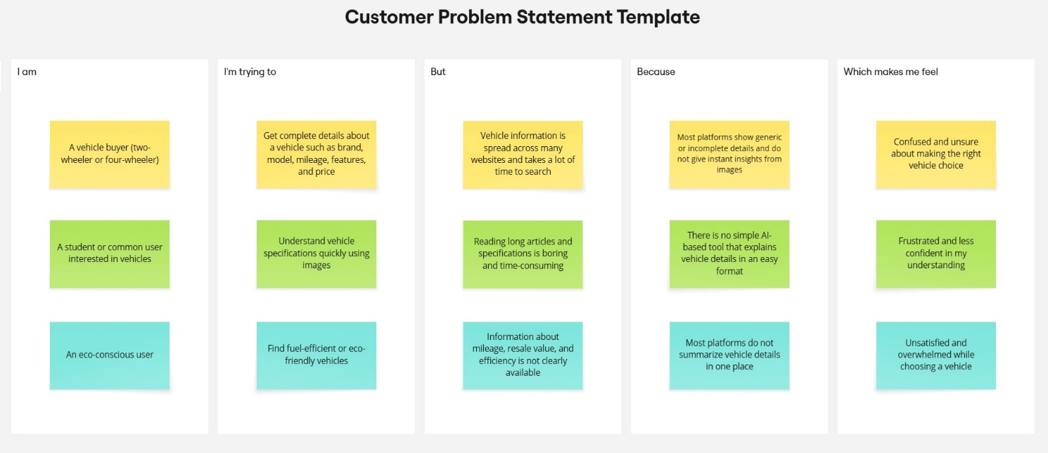

Problem  Statement (PS) | I am  (Customer) | I’m trying to | But | Because | Which makes me feel
PS-1 | A vehicle buyer | Understand vehicle details before buying a bike or car | Searching for vehicle information takes too much time | Vehicle details are spread across many websites and need manual comparison | Confused and unsure about choosing right vehicle
PS-2 | A student or general user | Identify and understand a vehicle using its image | Reading ling specifications and reviews is difficult | Most platforms do not support image-based vehicle analysis | Frustrated and less confident
PS-3 | An eco-conscious user | Find fuel-efficiency or eco-friendly vehicles | It is hard to get clear information about mileage and efficiency | Vehicle information is not summarized in one place | Dissatisfied and overwhelmed

2.2. Empathy Map Canvas
Empathy Map Canvas:
An empathy map is a simple, easy-to-digest visual that captures knowledge about a user’s behaviours and attitudes.

It is a useful tool to helps teams better understand their users.
Creating an effective solution requires understanding the true problem and the person who is experiencing it. The exercise of creating the map helps participants consider things from the user’s perspective along with his or her goals and challenges.
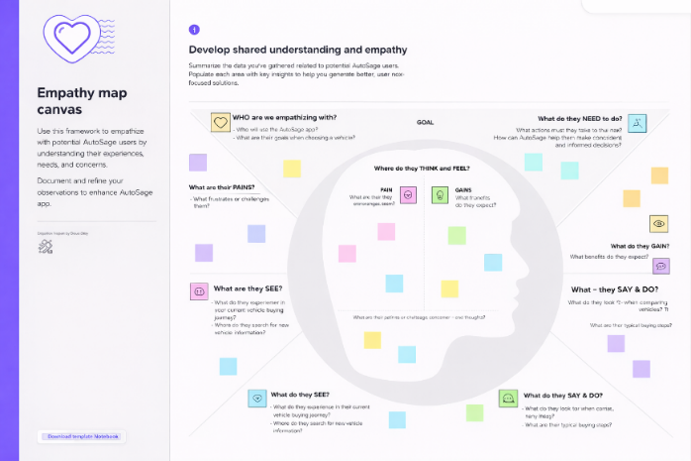
2.3 Brainstorming
Brainstorm & Idea Prioritization:
Brainstorming provides a free and open environment that encourages everyone within a team to participate in the creative thinking process that leads to problem solving. Prioritizing volume over value, out-of-the-box ideas are welcome and built upon, and all participants are encouraged to collaborate, helping each other develop a rich amount of creative solutions.
Step-1: Team Gathering, Collaboration and Select the Problem Statement
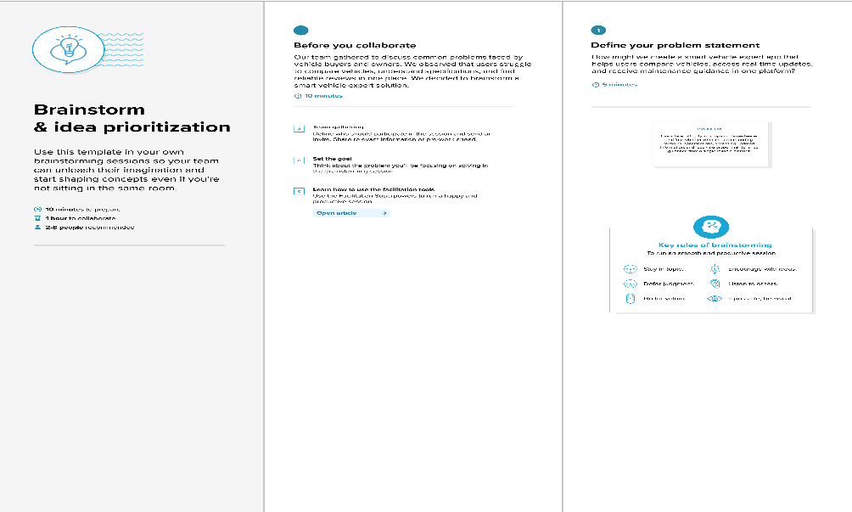

Step-2: Brainstorm, Idea Listing and Grouping
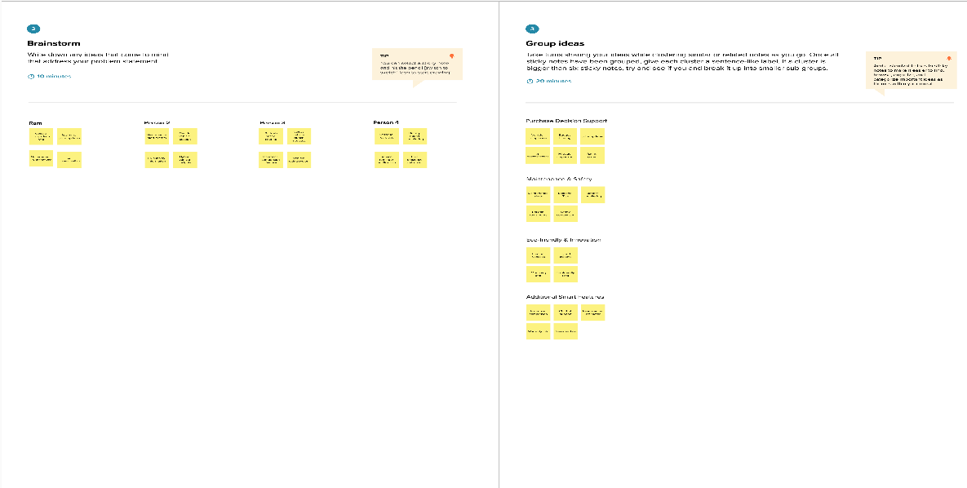

Step-3: Idea Prioritization
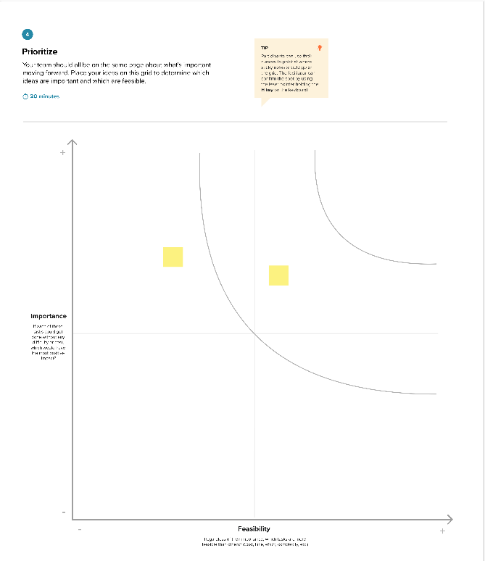
3. REQUIREMENT ANALYSIS
3.1. Solution Requirement
Functional Requirements:
Following are the functional requirements of the proposed solution.
FR No. | Functional Requirement (Epic) | Sub Requirement (Story / Sub-Task)
FR-1 | User Registration | Registration through email and password  Login using registered credentials
FR-2 | Vehicle Image Upload | Upload vehicle image (jpg, jpeg, png)  Validate uploaded image format
FR-3 | AI Vehicle Analysis | Analyze vehicle image using Gemini Flash  Generate structured vehicle details (brand, model, mileage, price)
FR-4 | Display Results | Display vehicle analysis results clearly on dashboard  Show structured output in readable format
FR-5 | Web Deployment | Deploy application using Streamlit  Access application via web browser

Non-functional Requirements:
Following are the non-functional requirements of the proposed solution.
FR No. | Non-Functional Requirement | Description
NFR-1 | Usability | The system should have a simple and user-friendly interface for easy image upload and result viewing.
NFR-2 | Security | User login data and inputs must be securely handled and protected.
NFR-3 | Reliability | The system should consistently generate vehicle details without frequent failures.
NFR-4 | Performance | Vehicle analysis results should be generated within a few seconds after image upload.
NFR-5 | Availability | The application should be accessible online whenever users access the deployed link.
NFR-6 | Scalability | The system should handle multiple users and future feature expansion.

3.2. Data Flow Diagram
Data Flow Diagrams:
A Data Flow Diagram (DFD) is a traditional visual representation of the information flows within a system. A neat and clear DFD can depict the right amount of the system requirement graphically. It shows how data enters and leaves the system, what changes the information, and where data is stored.

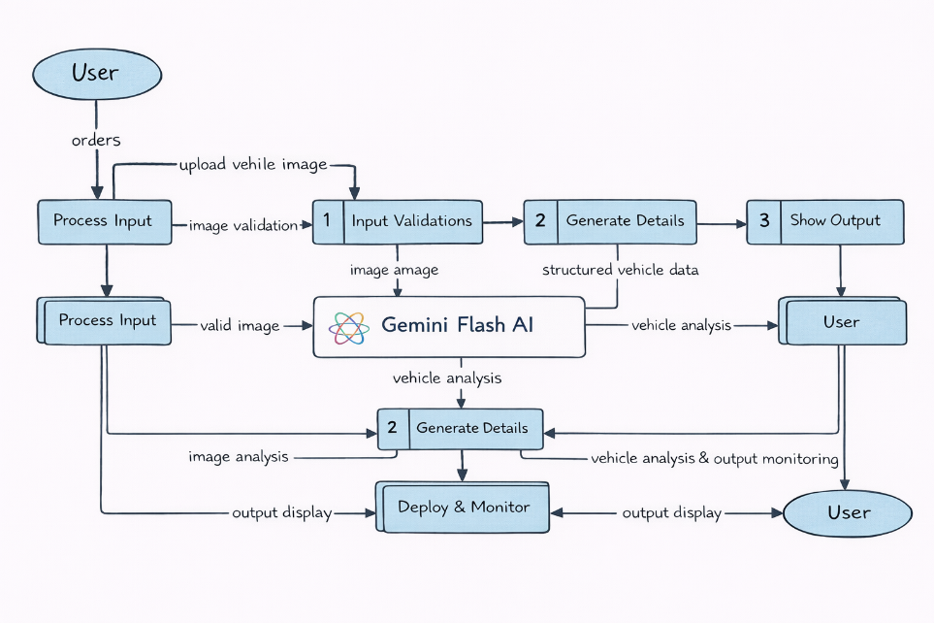
User Stories
Use the below template to list all the user stories for the product.
User Type | Functional Requirement (Epic) | User Story Number | User Story / Task | Acceptance criteria | Priority | Release
Customer (Mobile user) | Registration | USN-1 | As a user, I can register for the AutoSage application using email and password | User can successfully create account and access dashboard. | High | Sprint-1
 |  | USN-2 | As a user, I will receive confirmation email once I have registered for the application | User receives confirmation email and activates account. | High | Sprint-1
 |  | USN-3 | As a user, I can register using google account. | User can register and access dashboard via Google login. | Medium | Sprint-2
 | Login | USN-4 | As a user, I can log into the application by entering email & password | User can successfully log in and access dashboard. | High | Sprint-1
 | Dashboard | USN-5 | As a user, I can upload a vehicle image for analysis. | System accepts valid image formats and processes the image. | High | Sprint-1
 |  | USN-6 | As a user, I can enter a vehicle query(brand/model) manually | System accepts input and returns vehicle details. | High | Sprint-1
 | Vehicle Analysis | USN-7 | As a user, I want the system to analyze vehicle images using Gemini Flash AI | System extracts and displays vehicle details (brand, mileage, fuel type, price). | High | Sprint-2
 |  | USN-8 | As a user, I want structured vehicle details to be displayed clearly. | Vehicle details appear in organized readable format. | High | Sprint-1

3.3. Technology Stack
Technical Architecture:
The AutoSage application follows a simple 3-layer architecture:
- User Interface Layer (Streamlit Web App)
- Application Logic Layer (Python Backend + Gemini Flash API Integration)
- Data Layer (Vehicle Data & System Storage)
The system allows users to upload vehicle images, which are validated and processed using the Gemini Flash model to generate structured vehicle details. The results are displayed through a web-based interface.
Table-1 : Components & Technologies:
S.No | Component | Description | Technology
1 | User Interface | Web-based interface for users to upload vehicle images and view results | Streamlit (Python)
2 | Application Logic-1 | Image validation and processing logic | Python
3 | Application Logic-2 | AI-based vehicle image analysis | Gemini Flash API
4 | Application Logic-3 | Structured response generation (brand, mileage, price extraction) | Prompt Engineering (Python + Gemini)
5 | Database | Storage of vehicle-related information (if applicable) | SQLite / Local Storage
6 | File Storage | Temporary storage of uploaded vehicle images | Local File System
7 | External API-1 | AI model integration for vehicle analysis | Google Gemini Flash API
8 | Machine Learning Model | Image-based vehicle understanding and detail generation | Gemini Flash Multimodal Model
9 | Infrastructure (Server / Cloud) | Application deployment and hosting | Streamlit Cloud / Local System

Table-2: Application Characteristics:
S.No | Characteristics | Description | Technology
1 | Open-Source Frameworks | Frameworks used for building application | Streamlit, Python
2 | Security Implementations | Secure API key storage and input validation | Environment Variables, HTTPS
3 | Scalable Architecture | Modular design separating UI, Logic, and AI model integration | Layered Architecture
4 | Availability | Application accessible via browser once deployed | Streamlit Cloud
5 | Performance | Optimized image validation and fast AI response handling | Python Optimization + API Response Handling

4. PROJECT DESIGN
4.1. Problem Solution Fit
Problem – Solution Fit Template:
The Problem-Solution Fit simply means that you have found a problem with your customer and that the solution you have realized for it actually solves the customer’s problem. It helps entrepreneurs, marketers and corporate innovators identify behavioral patterns and recognize what would work and why
Problem – Solution Fit Template:
The Problem-Solution Fit means identifying the real problems faced by vehicle buyers and ensuring that the AutoSage solution effectively addresses those issues using AI-powered vehicle analysis.
Purpose:
☑ Solve vehicle comparison and information access problems efficiently.
☑ Help users make informed vehicle purchase decisions.
☑ Provide AI-based insights using Gemini Flash.
☑ Improve user confidence while selecting vehicles.
☑ Simplify vehicle analysis through image-based processing.

Template:

4.2. Proposed Solution
Proposed Solution Template:
Project team shall fill the following information in the proposed solution template.
S.No. | Parameter | Description
1 | Problem Statement (Problem to be solved) | Vehicle buyers face difficulty in comparing models, understanding specifications, and accessing reliable vehicle information from a single platform.
2 | Idea / Solution Description | AutoSage is an AI-powered vehicle expert application that allows users to upload vehicle images and receive structured vehicle details using Gemini Flash AI. It simplifies vehicle comparison and decision-making.
3 | Novelty / Uniqueness | The system uses image-based AI analysis instead of only manual search. Users can upload a vehicle image and instantly get structured details like brand, mileage, and price.
4 | Social Impact / Customer Satisfaction | AutoSage helps users make confident vehicle purchase decisions, reduces confusion, saves time, and improves overall customer satisfaction.
5 | Business Model (Revenue Model) | Freemium model: basic vehicle analysis is free, advanced comparison features and premium insights can be subscription-based.
6 | Scalability of the Solution | The system can be expanded to include more vehicle categories, cloud database integration, real-time market pricing, and mobile app deployment in the future.

4.3 Solution Architecture
Solution Architecture:
Solution architecture for AutoSage bridges the gap between the problem of unstructured vehicle information and the AI-based technological solution.
The architecture is designed to:
- Find the best AI-based solution for vehicle analysis and comparison.
- Define the structure and interaction between UI, backend logic, and AI services.
- Clearly describe how vehicle images are processed and analyzed.
- Provide specifications for deployment and system management.

Solution Architecture Diagram:

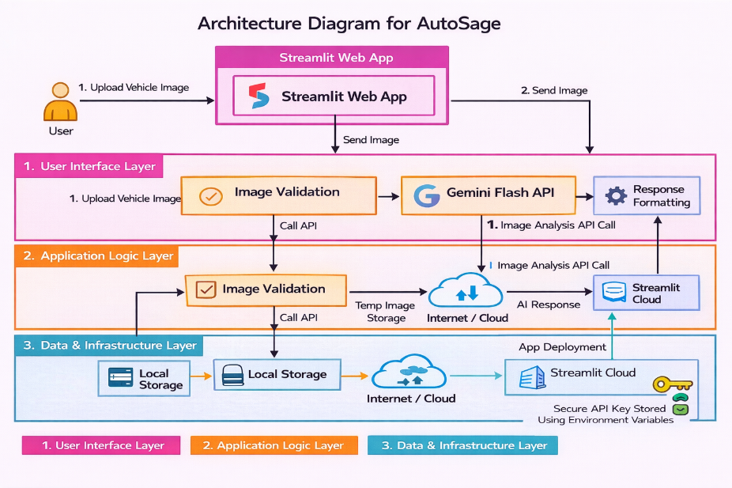

Figure 1 – Architecture Diagram for AutoSage app

5. PROJECT PLANNING & SCHEDULING
5.1. Project Planning
Product Backlog, Sprint Schedule, and Estimation (4 Marks)
The following table represents the product backlog and sprint-wise planning for the AutoSage project.
Sprint | Functional Requirement (Epic) | User Story Number | User Story / Task | Story Points | Priority | Team Members | Sprint Start Date | Sprint End Date (Planned)
Sprint-1 | User Interface Setup | USN-1 | As a user, I want a Streamlit-based interface to upload vehicle images easily. | 2 | High | All Team members | 28 January 2026 | 31 January 2026
Sprint-1 | Image Upload Validation | USN-2 | As a user, I want the system to validate the uploaded image format (jpg, jpeg, png). | 1 | High | All Team members | 28 January 2026 | 31 January 2026
Sprint-2 | AI Model Integration | USN-3 | As a user, I want the system to analyze vehicle images using the Gemini Flash model. | 3 | High | All Team members | 02 February 2026 | 09 February 2026
Sprint-2 | Prompt Engineering | USN-4 | As a user, I want the system to generate structured vehicle details like brand, mileage, and price. | 2 | High | All Team members | 02 February 2026 | 09 February 2026
Sprint-3 | Output Display | USN-5 | As a user, I want to view the generated vehicle details clearly on the screen. | 2 | High | All Team members | 12 February 2026 | 18 February 2026
Sprint-3 | Deployment | USN-6 | As a user, I want the AutoSage application to be deployed and accessible through the browser. | 2 | Medium | All Team members | 12 February 2026 | 18 February 2026

Project Tracker, Velocity & Burndown Chart: (4 Marks)
Sprint | Total Story Points | Duration | Sprint Start Date | Sprint End Date (Planned) | Story Points Completed (as on Planned End Date) | Sprint Release Date (Actual)
Sprint 1 | 20 | 4 Days | 28 January 2026 | 31 January 2026 | 20 | 31 January 2026
Sprint 1 | 20 | 4 Days | 28 January 2026 | 31 January 2026 | 20 | 31 January 2026
Sprint 2 | 20 | 8 Days | 02 February 2026 | 09 February 2026 | 20 | 09 February 2026
Sprint 2 | 20 | 8 Days | 02 February 2026 | 09 February 2026 | 20 | 09 February 2026
Sprint 3 | 20 | 7 Days | 12 February 2026 | 18 February 2026 | 20 | 18 February 2026
Sprint 3 | 20 | 7 Days | 12 February 2026 | 18 February 2026 | 20 | 18 February 2026
Sprint 1 | 20 | 4 Days | 28 January 2026 | 31 January 2026 | 20 | 31 January 2026

6. FUNCTIONAL AND PERFORMANCE TESTING
6.1 Performance Testing

Test Scenarios & Results
Test Case ID | Scenario (What to test) | Test Steps (How to test) | Expected Result | Actual Result | Pass/Fail
FT-01 | Image Upload Validation | Upload valid (jpg, png) and invalid (pdf, txt) files | Valid image formats accepted, invalid formats rejected with error message | System accepted valid images and rejected invalid formats correctly | Pass
FT-02 | Image Size Validation | Upload large size image beyond limit | System should restrict large file or process without crash | System handled image without crashing | Pass
FT-03 | Vehicle Analysis Generation | Upload vehicle image and click "Analyze" | Structured vehicle details (brand, model, mileage, price) generated | Vehicle details generated correctly | Pass
FT-04 | API Connection Check | Use valid and invalid Gemini API key | Valid key connects successfully; invalid key shows error | API responded correctly; error shown for invalid key | Pass
FT-05 | Output Display | Check if generated details are clearly displayed | Structured, readable output visible on screen | Output displayed in organized format | Pass
PT-01 | Response Time Test | Upload image and measure processing time | Response time should be under 5 seconds | Response generated within acceptable time | Pass
PT-02 | Multiple Request Test | Upload images multiple times sequentially | System should not crash or freeze | Application handled repeated requests smoothly | Pass

7. RESULTS

7.1 Output Screenshots
The complete execution of the AutoSage application is shown in the images step by step as shown below.

Step 1: Run the app.py code using streamlit run app.py and you will get a link in terminal http://localhost:8501 which opens automatically in the browser.

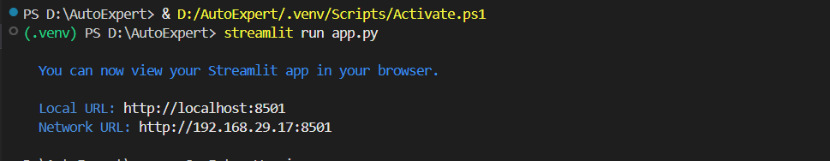

Fig 7.1.1: Code running in Terminal

Step 2: The link automatically opens to display the application.

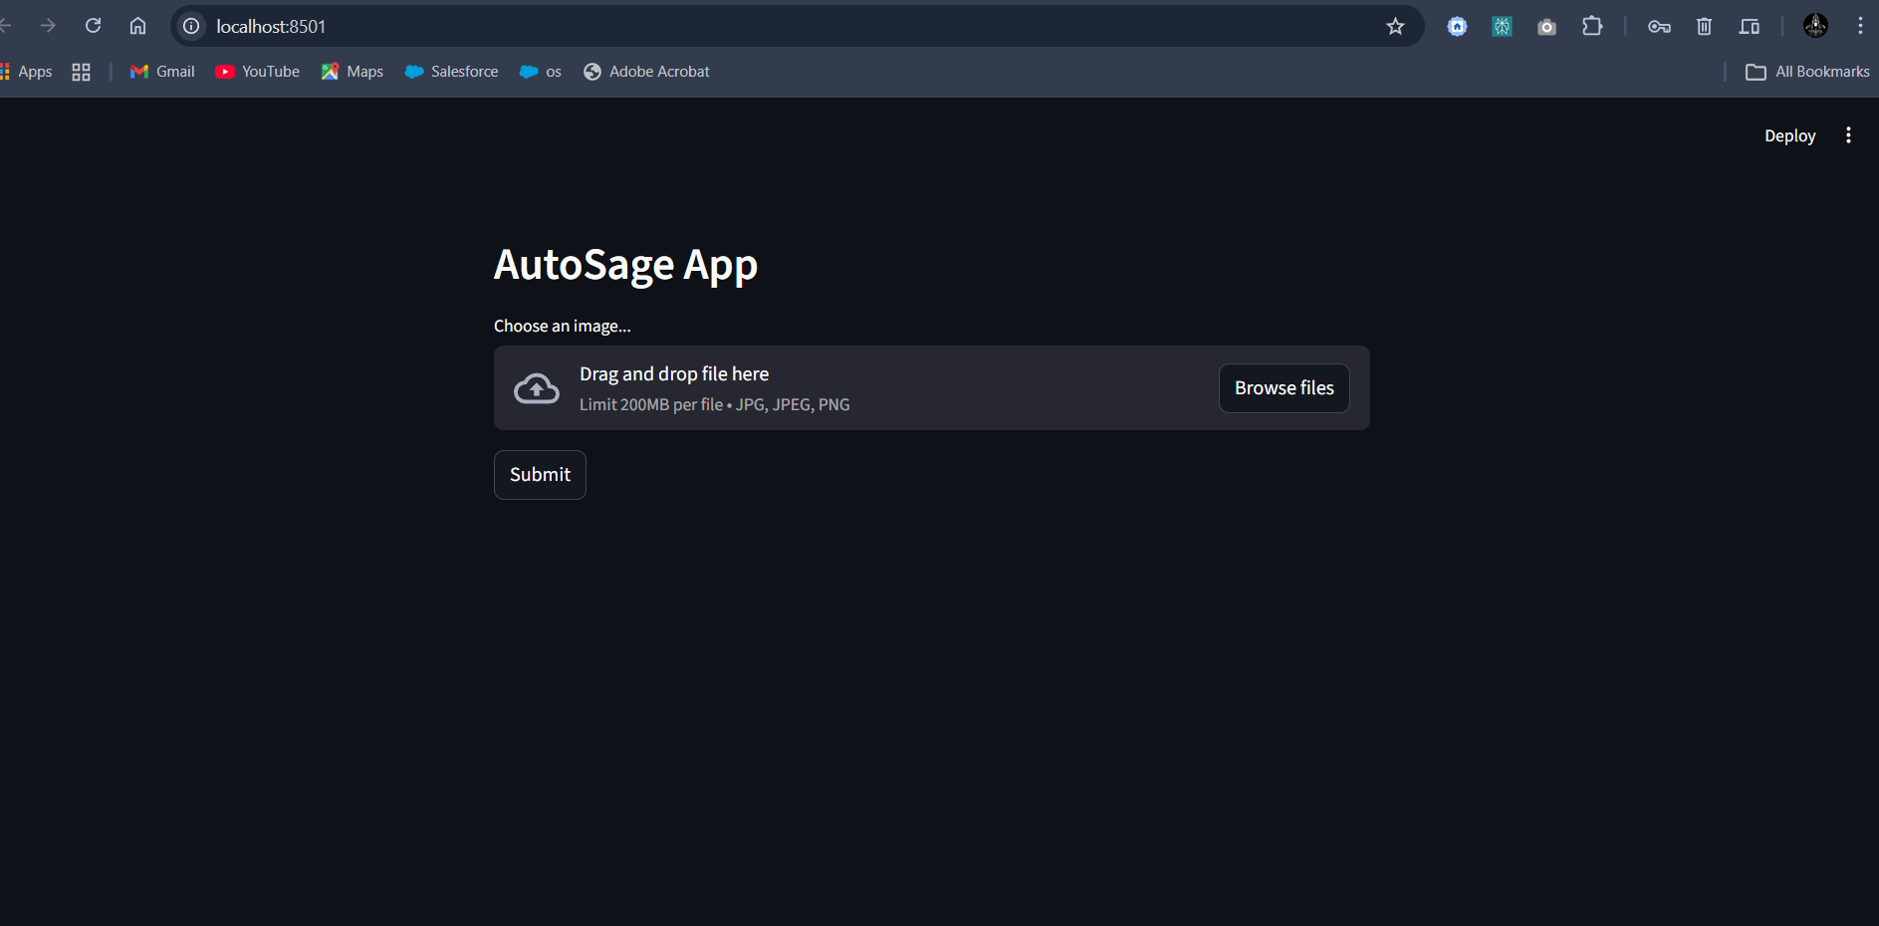

Fig 7.1.2: AutoSage App Page

Step 3: Click on Browse Files option to predict the vehicle details.

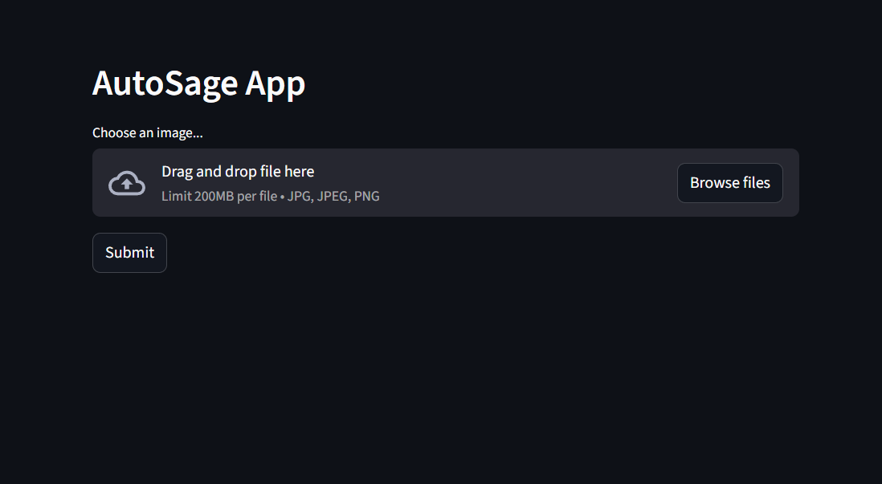
Fig 7.1.3: Prediction Page of AutoSage App

Step 4: Click on choose file option to choose the images that need to predict.

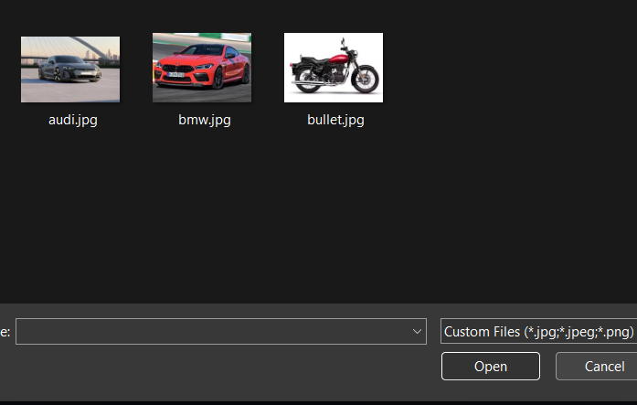
Fig 7.1.4: Window to choose image for prediction

Select any image for prediction and click on Open.

Step 5: The image loads into the application.

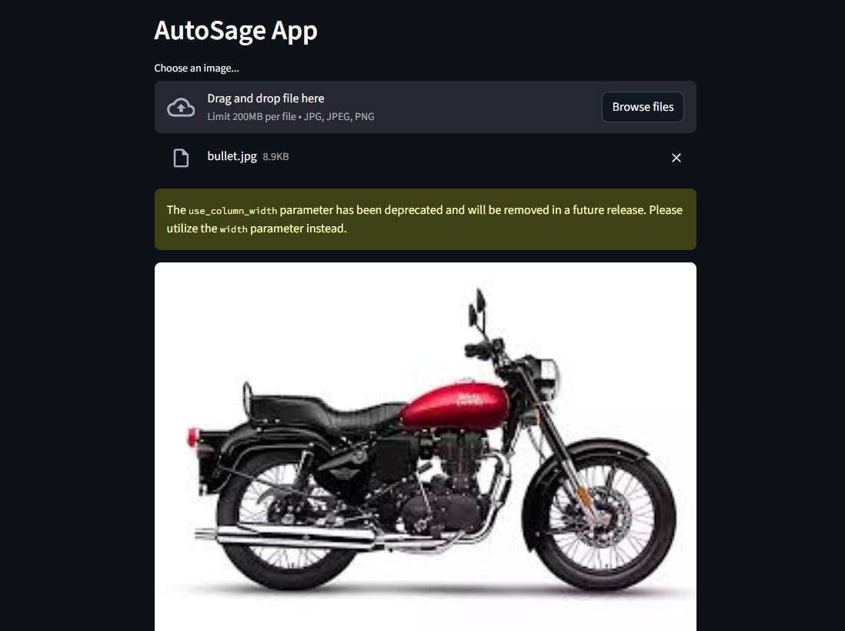

Fig 7.1.5: Image loads into the app.

Step 6: Now click on the Submit button to detect the type of vehicle and its details.

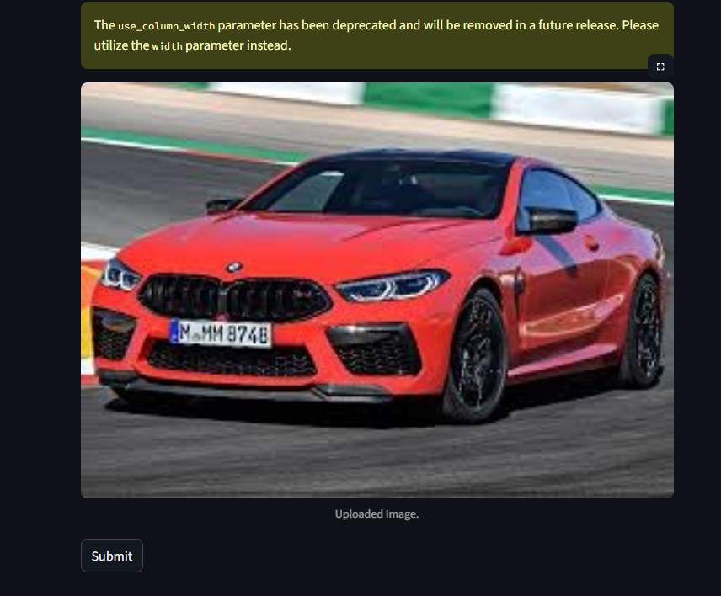

Fig 7.1.6: Click on submit to predict

Step 7: The model then predicts the type of the vehicle and provides its specifications as given below.


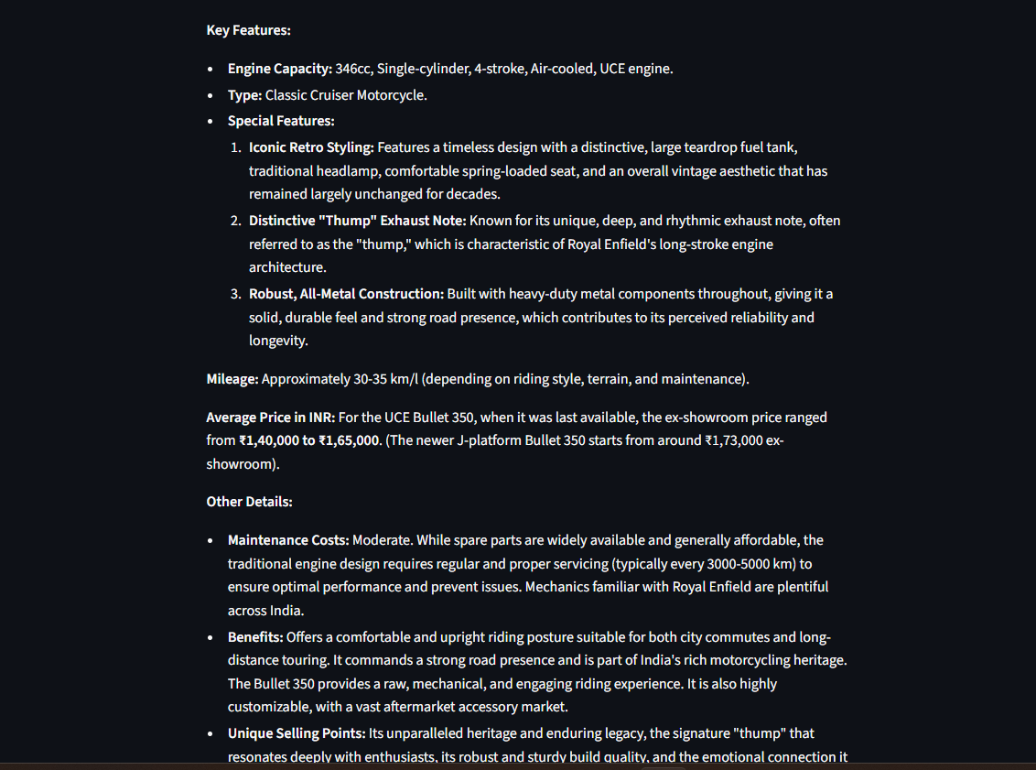
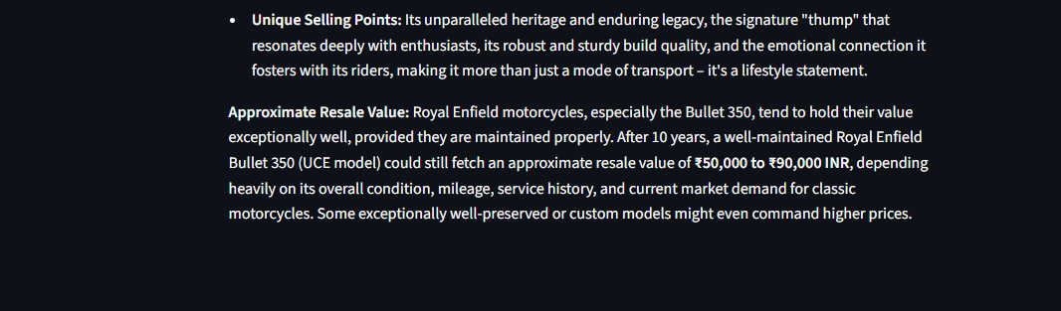
Fig 7.1.7: Output (Details of the vechicle)

8. ADVANTAGES & DISADVANTAGES
8.1 Advantages of AutoSage Project
Advantage | Description
Automated Vehicle Analysis | Automatically analyzes vehicle images and generates detailed information, reducing the need for manual research.
Fast & Real-Time Results | Gemini Flash provides quick responses, allowing users to get vehicle details instantly.
User-Friendly Interface | The Streamlit-based web application allows users to upload images and view results easily without technical knowledge.
Multimodal AI Capability | Supports both image and text input, enabling accurate understanding of vehicle visuals and descriptions.
Scalability | The application can be extended to support more vehicle types, brands, and additional features in the future.
Data-Driven Decisions | Helps users make informed vehicle purchase and maintenance decisions based on structured AI-generated insights.
Cost & Time Saving | Eliminates the need to visit multiple websites or consult experts, saving time and effort for users.
Table 8.1: Advantages
8.2 Disadvantages / Limitations
Disadvantage | Description
Dependence on Image Quality | Low-quality or unclear vehicle images may reduce the accuracy of generated information.
Internet Dependency | The application requires an active internet connection to access the Gemini API.
API Usage Limits | Free-tier API usage is limited and may cause temporary restrictions under heavy usage.
No Physical Inspection | The system cannot detect hidden mechanical issues or internal vehicle defects.
Requires API Key Security | Improper handling of API keys may lead to security or quota issues.
Table 8.2: Disadvantages

9. CONCLUSION
The AutoSage project successfully demonstrates the use of Generative AI to analyze vehicle images and generate structured vehicle information using the Gemini Flash model. By integrating a user-friendly Streamlit interface, the system allows users to upload vehicle images and instantly receive details such as brand, model, features, mileage, price range, and resale value. This approach reduces manual research, saves time, and supports informed decision-making for vehicle buyers and owners. Overall, AutoSage highlights the practical application of AI in the automotive domain and provides a strong foundation for future enhancements.

10. FUTURE SCOPE
The AutoSage project can be further enhanced by integrating additional features and technologies. In the future, the application can support video-based vehicle analysis to provide more accurate insights. Integration with official vehicle databases can improve data accuracy and reliability. The system can also be extended to include a mobile application for wider accessibility. Additionally, multi-language support and cloud deployment can be implemented to improve scalability and reach a larger user base.

11. APPENDIX
11.1 Source Code
The complete source code for the AutoSage project is implemented using Python, Streamlit, and the Google Gemini API. The code includes modules for image upload, AI model integration, prompt handling, and output display.

10.2 GitHub & Project Demo Link
The source code and project demonstration video are hosted on GitHub. The repository contains all required files, including the application code, documentation, and setup instructions.
- GitHub Repository: https://github.com/Vijaykumar141512/AutoSage-App-Using-Gemini-Flash
- Project Demo Video: https://drive.google.com/file/d/1HnvjFWvaC27rWGnaaJj6XGAbiTCJRxW_/view?usp=sharing

